Missionaries and Cannibals Problem
Aim
To implement the Missionaries and Cannibals Problem using Python and find a safe sequence of moves to transport all missionaries and cannibals from one side of the river to the other.
Objective
To solve the Missionaries and Cannibals problem using Breadth First Search (BFS) while ensuring that the missionaries are never outnumbered by cannibals on either side of the river.
Algorithm
- Start with 3 missionaries and 3 cannibals on the left side.
- Set the initial state as (3, 3, 0, 0, 0).
- Represent the state as:
  - ML = Missionaries on the left
  - CL = Cannibals on the left
  - MR = Missionaries on the right
  - CR = Cannibals on the right
  - B = Boat position
- Check whether the current state is valid.
- Generate all possible boat movements:
  - 1 Missionary
  - 1 Cannibal
  - 2 Missionaries
  - 2 Cannibals
  - 1 Missionary and 1 Cannibal
- Move the selected people across the river.
- Check whether the new state is valid.
- Add the valid unvisited state to the queue.
- Repeat until the goal state (0, 0, 3, 3, 1) is reached.
- Display the solution path.

Flowchart

Python Code

from collections import deque

def is_valid(state):
ml, cl, mr, cr, boat = state

if ml < 0 or cl < 0 or mr < 0 or cr < 0:
return False

if ml > 3 or cl > 3 or mr > 3 or cr > 3:
return False

if ml > 0 and ml < cl:
return False

if mr > 0 and mr < cr:
return False

return True

def get_next_states(state):
ml, cl, mr, cr, boat = state

moves = [
(1, 0),
(0, 1),
(2, 0),
(0, 2),
(1, 1)
]

next_states = []

for m, c in moves:
if boat == 0:
new_state = (
ml - m,
cl - c,
mr + m,
cr + c,
1
)
else:
new_state = (
ml + m,
cl + c,
mr - m,
cr - c,
0
)

if is_valid(new_state):
next_states.append(new_state)

return next_states

def bfs():
initial_state = (3, 3, 0, 0, 0)
goal_state = (0, 0, 3, 3, 1)

queue = deque()
queue.append((initial_state, [initial_state]))

visited = set()
visited.add(initial_state)

while queue:
state, path = queue.popleft()

if state == goal_state:
return path

for next_state in get_next_states(state):
if next_state not in visited:
visited.add(next_state)
queue.append((next_state, path + [next_state]))

return None

solution = bfs()

if solution:
print("Solution Found:")
print()

for i, state in enumerate(solution):
ml, cl, mr, cr, boat = state

if boat == 0:
boat_position = "Left"
else:
boat_position = "Right"

print(
"Step", i,
": Left(M =", ml, ", C =", cl, ")",
" | Right(M =", mr, ", C =", cr, ")",
" | Boat =", boat_position
)
else:
print("No solution found.")

Output

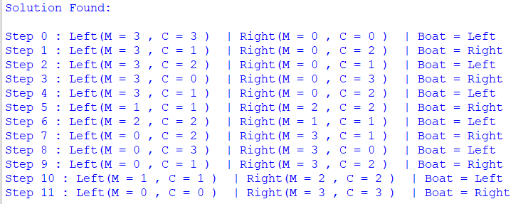
Result
The Missionaries and Cannibals problem was successfully solved using the Breadth First Search (BFS) algorithm. The program finds a sequence of valid states that safely transports all missionaries and cannibals to the opposite side of the river.
Conclusion
The program successfully demonstrates how state-space search and BFS can be used to solve the Missionaries and Cannibals problem. The solution ensures that the missionaries are never outnumbered by cannibals on either side of the river.

